**Music Store data analysis Project using SQL**

1. Who is the senior most employee based on job title?

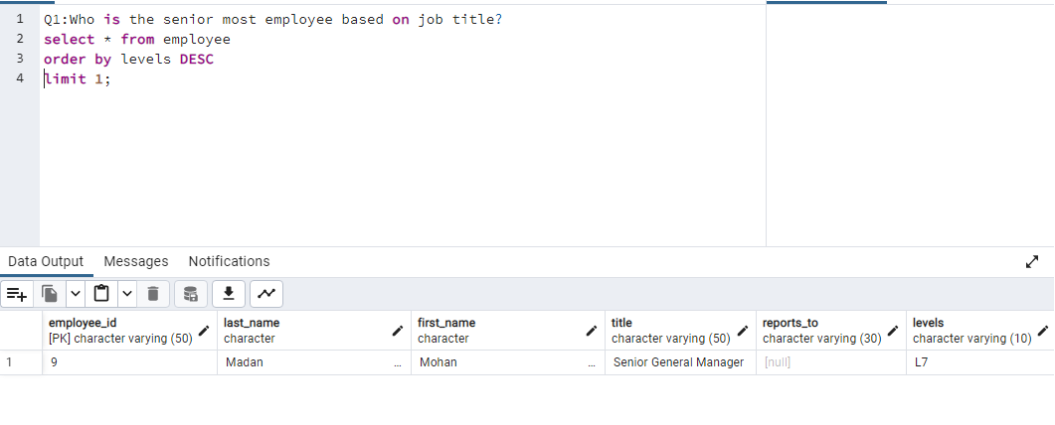

2. Which countries have the most Invoices?

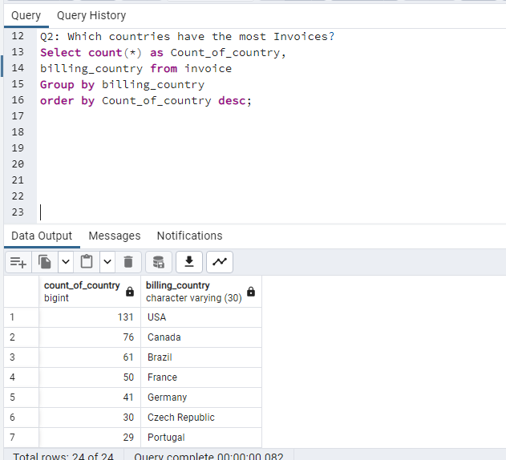

3. What are top 3 values of total invoice?

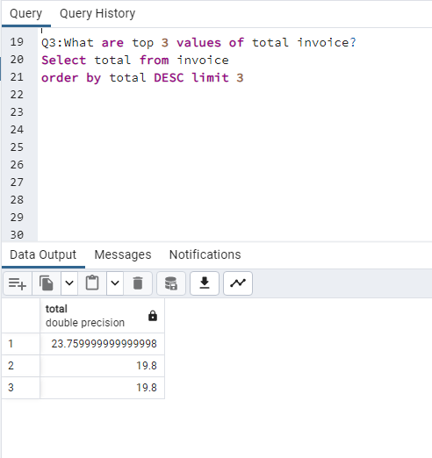

Q4 . Which city has the best customers? We would like to throw a promotional Music

Festival in the city we made the most money. Write a query that returns one city that

has the highest sum of invoice totals. Return both the city name & sum of all invoice

totals.

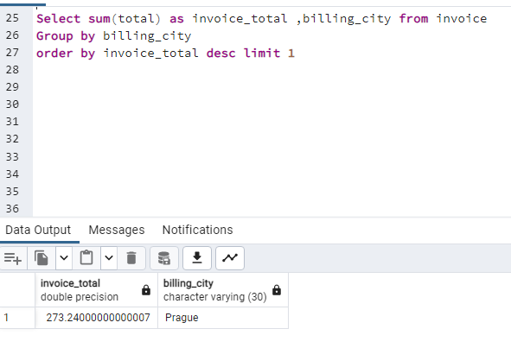

Q5. Who is the best customer? The customer who has spent the most money will be

declared the best customer. Write a query that returns the person who has spent the

most money

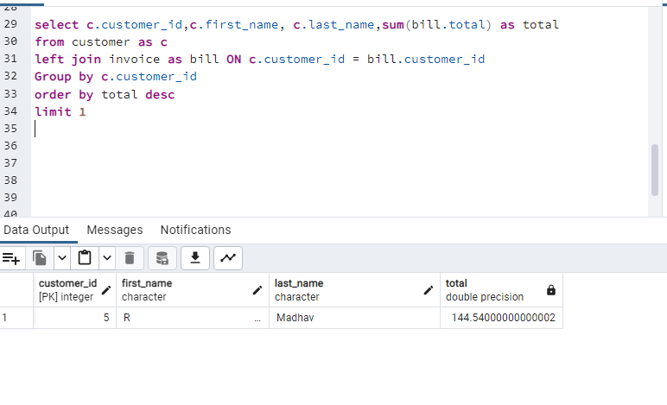

Q6. Write query to return the email, first name, last name, & Genre of all Rock Music

listeners. Return your list ordered alphabetically by email starting with A

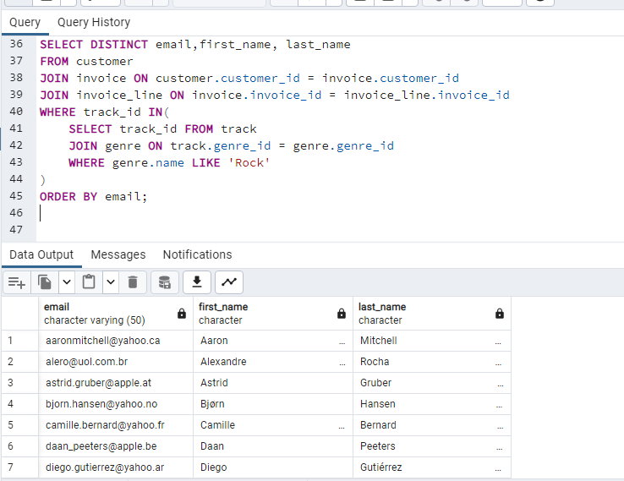

Q7. Let's invite the artists who have written the most rock music in our dataset. Write a

query that returns the Artist name and total track count of the top 10 rock bands

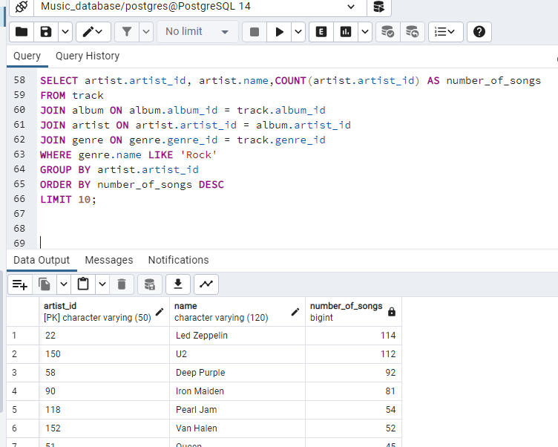

Q8. Return all the track names that have a song length longer than the average song length.

Return the Name and Milliseconds for each track. Order by the song length with the

longest songs listed first

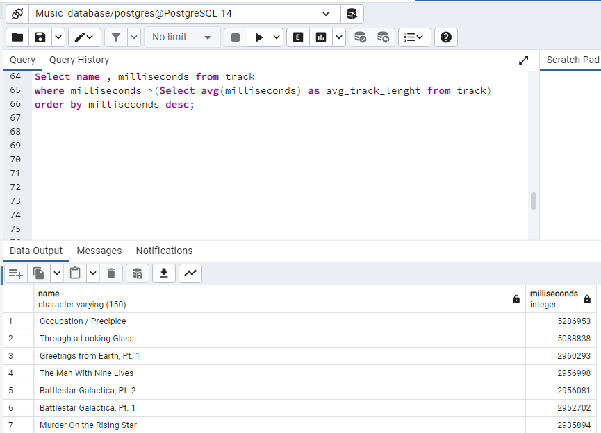

Q9. Find how much amount spent by each customer on artists? Write a query to return

customer name, artist name and total spent.

WITH best_selling_artist AS (

SELECT artist.artist_id AS artist_id, artist.name AS artist_name, SUM(invoice_line.unit_price*invoice_line.quantity) AS total_sales

FROM invoice_line

JOIN track ON track.track_id = invoice_line.track_id

JOIN album ON album.album_id = track.album_id

JOIN artist ON artist.artist_id = album.artist_id

GROUP BY 1

ORDER BY 3 DESC

LIMIT 1

)

SELECT c.customer_id, c.first_name, c.last_name, bsa.artist_name, SUM(il.unit_price*il.quantity) AS amount_spent

FROM invoice i

JOIN customer c ON c.customer_id = i.customer_id

JOIN invoice_line il ON il.invoice_id = i.invoice_id

JOIN track t ON t.track_id = il.track_id

JOIN album alb ON alb.album_id = t.album_id

JOIN best_selling_artist bsa ON bsa.artist_id = alb.artist_id

GROUP BY 1,2,3,4

ORDER BY 5 DESC;

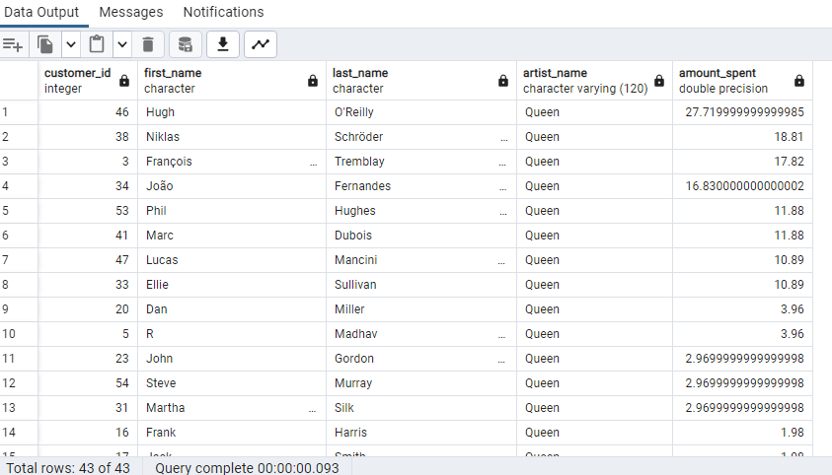

Q10. We want to find out the most popular music Genre for each country. We determine the

most popular genre as the genre with the highest amount of purchases. Write a query

that returns each country along with the top Genre. For countries where the maximum

number of purchases is shared return all Genres.

WITH popular_genre AS

(

SELECT COUNT(invoice_line.quantity) AS purchases, customer.country, genre.name, genre.genre_id,

ROW_NUMBER() OVER(PARTITION BY customer.country ORDER BY COUNT(invoice_line.quantity) DESC) AS RowNo

FROM invoice_line

JOIN invoice ON invoice.invoice_id = invoice_line.invoice_id

JOIN customer ON customer.customer_id = invoice.customer_id

JOIN track ON track.track_id = invoice_line.track_id

JOIN genre ON genre.genre_id = track.genre_id

GROUP BY 2,3,4

ORDER BY 2 ASC, 1 DESC

)

SELECT * FROM popular_genre WHERE RowNo <= 1

